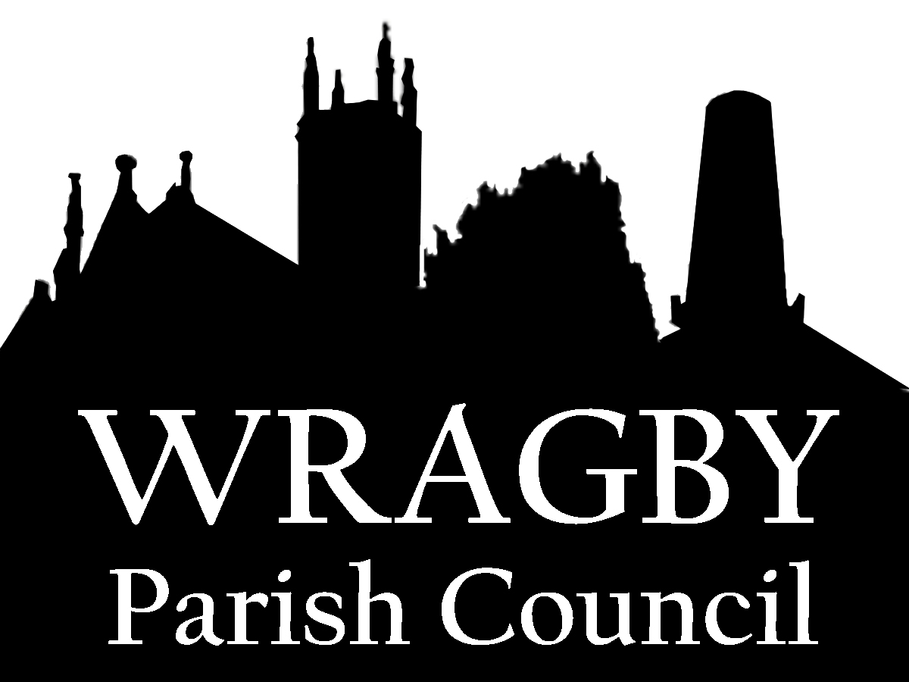
PARISH COUNCIL GRANTS 2025/26

GUIDANCE NOTES

The Parish Council has resolved that each financial year it will set aside an amount of money for grant purposes.

These grants are only available for use within the Wragby Parish area and should benefit all or some of the Wragby Parish Community. These grants are only intended for a proven need (eg., to fund specific projects or purchases) rather than day-to-day expenditure like rent, business rates, other running expenses, etc.

If Applicants have any queries about the Application Form and/or what is required, please do not hesitate to contact Carl Thomas, Clerk to the Council.

Applicants should note that they may be asked for further information and that they may receive all, some or none of the amount they apply for and that the decision of the Parish Council is final.

The Application Form should be completed in full and must be submitted, together with any supporting documentation, to the Clerk by Friday 25th April 2025.

The Parish Council will take into account the following criteria:-

- Time since any previous application
- Previous grants awarded
- Supporting evidence as to how previous grants have been used
- Number of the Wragby Parish Community that may benefit from the grant
- Funds raised elsewhere
- Urgency of need
- Use of the Parish Council’s grant to allow access to other organisations grants/funds

Please note that, if approved, grants will be paid by the Parish Council in May 20258

Please return the completed grant application form and any supporting documentation to the address below or via email.

The Clerk’s contact details are:- Carl Thomas
Wragby Parish Council
28 Allington Drive
Great Coates
Grimsby
DN37 9FF

Email: clerk@wragbyparishcouncil.gov.uk

APPLICATION FOR GRANT 2025/26
WRAGBY PARISH COUNCIL

Name of Organisation

Total Membership of Organisation
Total Membership living within Wragby Parish Area
Applicant’s Name

Position within the Organisation

Contact Address

Contact Email

Contact Telephone Number

Amount of Grant applied for

Purpose of Grant
(Please continue on another sheet if required)
Has funding been sought elsewhere and, if so, where?

Any other comments in support of your application
(Please continue on another sheet if required)

Bank details for payment of grant. |  | Sort Code:  Account No:  Account Name:
Please provide a copy of your most recent audited accounts.
(Please note that the Council is unable to consider applications that are not supported by adequate financial documentation)

Name of person applying for the grant

Signature of person applying or the grant

